Michigan
“Where it all began”

Michigan SACC Volume 2, Issue 2 Spring/2 2011
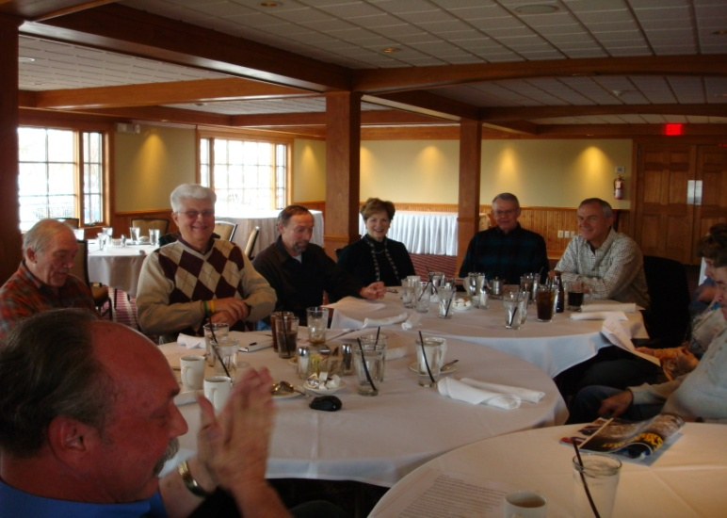

2011 Chapter Activities

April 23, 2011 BOARD MEETING
Brookshire Inn & Golf Club
Williston, MI
10:00 AM

Fellow MCSACC members,

A general reorganizational meeting was held at Karl’s Cabin in Plymouth on March 13, 2011. The focus of the meeting was to reestablish the Michigan SACC Chapter as a functioning group dedicated to the preservation and enjoyment of Chevrolet’s finest – our C1s. Thirteen members were present for the election of 2011/2012 officers. See last page for results.

We also discussed activities, tech sessions and membership development. Several activities were considered and a minimum of four events for 2011 are to be planned and executed.

The proposed events are:

May 15 Spring Road Tour
Marshall, MI

July 9 Corvettes at the Summit
Heritage Park, Canton, MI

Sept 18 Paragon
Swartz Creek, MI

Oct ?? Frankenmuth Color Tour or
Lake Huron/Lighthouse Tour

Events of other organizations of interest will be included upon request to the Editor. See www.carshownews.com 4 more..

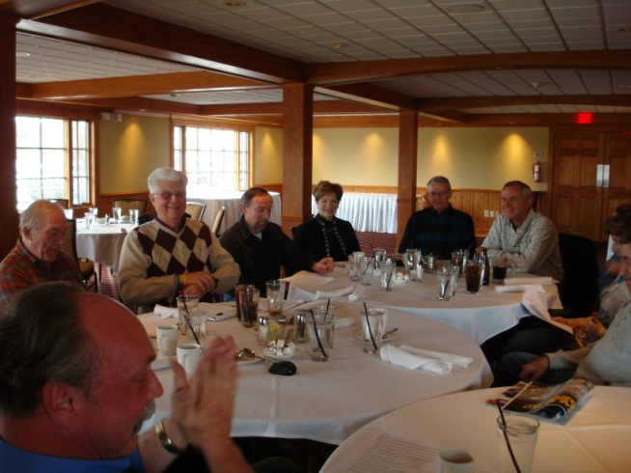
Bill Huffman, John Hutchins, Harry Jones, Paul Lemieux, Sue and Dave Ruby and Rick Smith at Mar 13 Gen Membership meeting

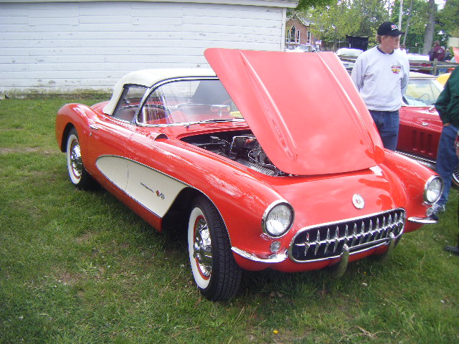

Jack and Carol Smith’s 1957 Fuelie

Michigan Chapter E-mail: MI_SACC@yahoo.com
of the Solid Axle Corvette Club Website: future plans – looking for a volunteer

President’s Message:
Greetings Michigan Solid Axle enthusiasts:

It is SOP for the president of any organization to write a short introductory message in the “Company Newsletter”. From the Desk of the President seems fairly presumptuous for a guy who was only just a crazy old Corvette owner the day before. I will do my best to serve both you folks and SACC national organization as well. Let’s make this something to be proud of.

Playing with Corvettes for the last 40 + years has taught me some things..

- Don’t start something if you don’t intend to finish it.
- If it’s worth doing, it’s worth doing well.
- Doing it wrong is just as much work as doing it right, it just costs more.
- If you don’t do it right the first time, you get to do it over.
I look forward to meeting all of you and hope you are able to make it to our scheduled events. If you do, you will be surprised how quickly new acquaintances become old friends. The focus of the Michigan Chapter and every other chapter of SACC is the enjoyment of driving that antique of yours. If it’s in primer or has sagging springs bring it along anyway. We’ve all been there & done that. Sounds like an opportunity for a tech session to me !

Remember to wave as your fellow Corvette owners drive past. They may not be old enough to know what a real Corvette looks like.

Bill Huffman

Corvette Fever…Never say never!!!
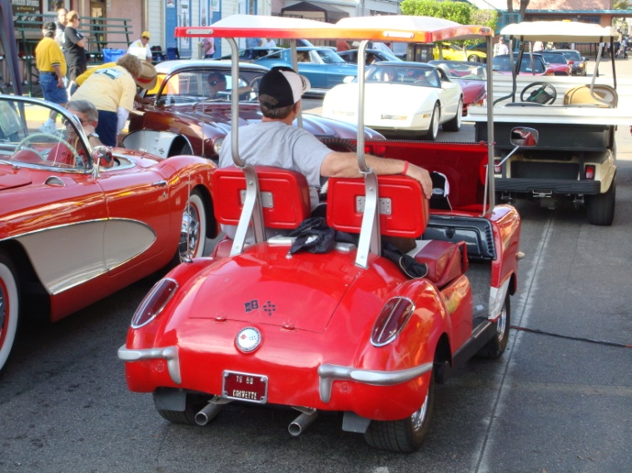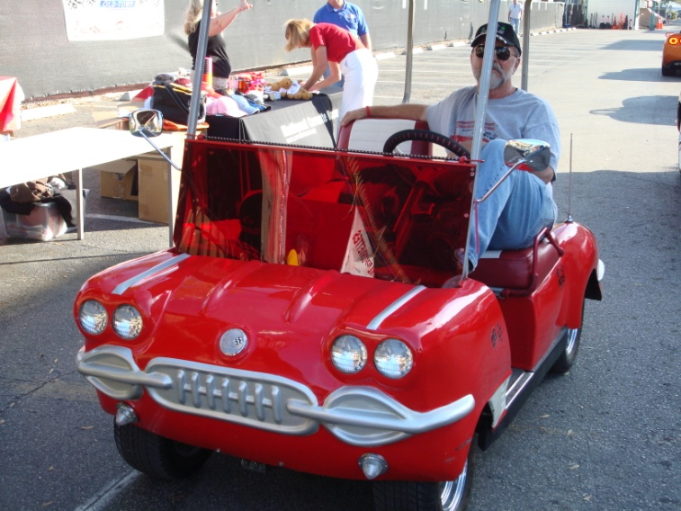

Technically Speaking…

... a voice of experience By John Hutchins

This column is intended to be a question and answer forum for Chapter members who are seeking assistance with particular restoration issues concerning the Solid Axle Cars. You are invited to submit questions via email kjhh41@hotmail.com Please put “SACC Tech question” in your subject line. I will attempt to address the questions promptly and if I do not have an answer I will try to seek the help of others. Issues thought to be of the greatest interest will be selected for publication here. I have a greater amount of information on the 53-57 cars than I do on the 58-62 years.

A 54 owner asks: “I would be interested to know what you consider to be the
rarest among the earliest (53-55) Corvettes.”

In my book, it would have to be one of the seven 1955’s built with the six cylinder engine. Three were painted Red, two were Harvest Gold, One was Polo White. The other one the original color has not been determined.

53-55 CORVETTE RELATIVE RARITY
1955 w/ a 6 cylinder engine 6-7
1955 w/ 3 speed transmission 30

Motorama body/White Elephant/C-1r”
1953 in Polo White 300
All 53-55’s in Polo White 3825
All colors (other than white) 53-55 815
“53 type” bodied early 1954’s 300 apx

1954 in Polo White 3200 apx
1954 in Black 15-20 apx
1954 in Sportsman Red 100
1954 in Pennant Blue 310

1955 in Polo White 325
1955 in Corvette Copper 15
1955 in Pennant Blue 45
1955 in Harvest Gold 120
1955 in Gypsy Red 180

The figures in some cases are approximate and in others based on survey percentages. It is also very possible that in 54 especially some units may have been assembled in primer and painted later off line by GM or in dealerships. This number is unknown.

A FURTHER NOTE ABOUT COLOR:

As you may know, there is no body data plate on these cars to indicate color from the factory. Generally, it is very easy to change the color during a body off full restoration and I am sure this has been done a number of times even back in ’54 at the hands of a dealership before delivery to the first owner. The figure of 100 red 54’s first come from averages based on an owner survey done in the 70’s and is an approximation. There is no factory document that I am aware of that says “100” nor for “300” Pennant Blue or any specific number for Black except 4 or more. I am of the opinion that generally there were no 54’s of color until the spring introduction of Pennant Blue in April. This was at around car number 54-1750; give or take a few. It is always possible that there were earlier red cars and perhaps black that were manufactured on a COPO basis as the paints were available even in ’53, but not blue. I tend to believe and have faith that the numbers are relatively correct but they should be used as a guide only. The only numbers of absolute certainty are: 300=53’s, 3640=54’s and 700=55’s.

Future Newsletter publication dates – February, May, August, November

EDITOR COMMENTS – DAVE RUBY

We hope that the newsletter will provide you with useful information and that it will continue to grow. We expect the basic format of the newsletter to be flexible and to that end we have left open what we publish—essentially, if it is of interest to the Michigan SACC community, we will print it. Obviously, we won’t reprint copyrighted material without permission, but anything original should find its way into the pages.

Generally, I’ll run whatever you send in as you prepared it, however, I reserve the right to edit for “good taste” and, of course, I’ll correct obvious spelling or grammar errors. We will be keeping the length of Michigan to a reasonable length, so depending on the amount of information we have for publication; your input may have to wait for the next issue. But, rest assured it will find its way into the newsletter.

We plan to send the newsletter out in February, May, August, and November. Therefore, please send items for publication to me by the 10th of the preceding month.

In summary, this is your newsletter—I just cut and paste the pieces together. So if there is something you would like to see here, please let me know. E-mail: druby@comcast.net, mail: 30120 Lincolnshire E., Beverly Hills, MI 48025

We shall distribute the newsletter as an electronic copy, via e-mail: We will mail the newsletter to those who do not have email.

Please direct all comments to druby@comcast.net

Links of Interest

Corvette Central | www.corvettecentral.com
Eckler’s Corvette Parts & Accessories | www.ecklers.com
Mid America Motorworks | www.motorworks.com
Mid Atlantic Chapter SACC (MACSACC) | www.masacc.org
National Corvette Museum (NCM) | www.corvettemuseum.com
National Corvette Restorers Society (NCRS) | www.mcrs/prg
Northwest Chapter SACC (NWSACC) | www.nwsacc.org
Paragon Reproductions | www.corvette-paragon.com
Solid Axle Corvette Club (SACC national) | www.solidaxle.org
Central Great Rivers Chapter  America’s Corvette club | www.casscomm.com/~wcic/  www.americascorvetteclub.org/
Car Show Central www.carshowcentral.com/

National Cherry Festival www.cherryfestival.org/events/everything.php

Corvette Clocks by Roger www.corvetteclocks.com

Zip Products www.zip-corvette.com

Welcome to the Michigan Chapter
SOLID AXLE CORVETTE CLUB
Michigan SACC Chapter Membership Application for 2011

Michigan SACC Chapter Membership requires membership in the National SACC
organization. To make record keeping easier Michigan SACC collects both National
and Chapter dues and submits National dues to the National office.
Annual Chapter dues are $15.
National SACC dues are $35. renewable every December.

Chapter dues include our quarterly Chapter Newsletter “Michigan”

National Membership includes the quarterly magazine “On Solid Ground”

If you are a new member the National SACC will send you a National membership number separately.
See WWW.solidaxle.org/forms for National membership application form.

If you are an existing National member please insert your National membership #____________

Please make checks payable to: MISACC and mail to:

Kelvin Wilbon
MI SACC Treasurer
PO Box 978
Davison MI 48423-0978 Questions: MI_SACC@yahoo.com

Applicant Name ______________________________________________________

Co-Applicant: ________________________________________________________

Address _____________________________________________________________

City _____________________________________State: _______Zip:___________

Home phone _________________________Work/Cell: ______________________

E-Mail _____________________________________ Fax: ____________________

Corvettes presently owned - please include the Serial # for all C-1’s

___________________ ___________________ ____________________ ___________________

I will enjoy participating in these club activities: Driving tours___ Get away weekends ___

Museum tours ___ Historic site/shop tours ___ Car Shows ___ Tech sessions ___ Race events___

Newsletter Contributions ___ Tour/Event Planning ___ Other______________________________

I would be interesting of chairing an event or gathering. Yes____ No____

Description of the event or gathering___________________________________________________

I am currently a member of the following Automotive clubs/organizations:

Michigan Chapter SACC

2011 Board of Directors

President: Bill Huffman
2200 N Sandstone Road
Jackson, MI 49201

Vice President: Tom Gamache
45451 Augusta Drive
Canton, MI 48188

Secretary: John Hutchins
9417 N. Rich Rd.
Alma, MI 48801

Treasurer: Kelvin Wilbon
P.O. Box 978
Davison, MI 48423-0978

Membership: Vacant

Editor: Sue & Dave Ruby
30120 Lincolnshire E.
Beverly Hills, MI 48025

Tech Advisor: John Hutchins

Event Organizer: Vacant

Questions & inquiries: MI_SACC@yahoo.com

Road Rules

The Michigan is the quarterly newsletter for the Michigan Chapter of the Solid Axle Corvette Club and is published four times yearly (Spring, Summer, Fall & Winter). A copy is sent to each member in good standing.

Membership in the Michigan Chapter is open only to members of the parent organization, the Solid Axle Corvette Club. The Solid Axle Corvette Club is a non-profit organization, serving members with an interest in 1953—1962 model year Corvettes. Ownership of a Solid Axle or any Corvette is not necessary to become a member of the organization.

The newsletter provides a forum for members to communicate with other members. As a result, the newsletter will often contain member opinions. Those opinions should not be construed as an endorsement by Michigan SACC or the parent organization, SACC.

Direct SACC National Membership questions to:

Lucy Badenhoop, SACC
P.O. Box 2288
N. Highlands, CA 95660

e-mail: badenhoop@comcast.net

SACC Michigan membership inquiries and corrections to the address list should be directed to our Treasurer:

Kelvin Wilbon
P.O. Box 978,
Davison, MI 48423-0978

e-mail: MI_SACC@yahoo.com

Please submit articles for publication to the editor. Generally, articles for publication should follow the broad theme of “Anything of interest to the Solid Axle Corvette community”. Suggested items for publication would include how-to articles, parts information, performance issues, scheduled events, restoration or repair information, and personal stories.

The Michigan editor can be reached at:

Dave Ruby, Editor
Michigan Chapter SACC
30120 Lincolnshire East
Beverly Hills, MI 48025

e-mail: druby@comcast.net

